CODE:ECA5614 NAME:M.DILLI GANESH
COURSE:5G-6G COMMUNICATION SYSTEMS REG NO:192412276

1.Simulation of LTE throughput performance under varying bandwidth, SNR,
modulation order, coding rate, and user load (BL4)
Aim
To analyze how LTE throughput changes with different bandwidths, SNR values, modulation orders, coding rates, and user loads.
Parameters
- Bandwidth: 5, 10, 15, 20 MHz
- SNR: 0–30 dB
- Modulation: QPSK, 16-QAM, 64-QAM
- Coding Rate: 1/3, 1/2, 3/4
- Number of Users: 10, 20, 50, 100
Procedure
- Create LTE network.
- Set bandwidth.
- Change SNR.
- Select modulation.
- Select coding rate.
- Increase users.
- Measure throughput.
Output Graphs
- Throughput vs SNR
- Throughput vs Bandwidth
- Throughput vs Number of Users
Expected Result
- Higher bandwidth → Higher throughput
- Higher SNR → Higher throughput
- 64-QAM gives highest throughput
- More users share resources, reducing throughput per user
Code:
clc;
clear;
close all;

% Parameters
bandwidth = [5 10 15 20]; % MHz
snr = 0:2:30; % dB
codingRate = 0.5; % Coding Rate
users = 20; % Number of Users

% Spectral Efficiency (bits/s/Hz)
modulation = {'QPSK','16QAM','64QAM'};
efficiency = [2 4 6];

figure;

for m = 1:length(modulation)

throughput = zeros(length(bandwidth),length(snr));

for b = 1:length(bandwidth)

BW = bandwidth(b)*1e6; % Hz

for s = 1:length(snr)

% Simple SNR efficiency factor
snrFactor = log2(1 + 10^(snr(s)/10));

% Throughput calculation
throughput(b,s) = ...
BW * efficiency(m) * codingRate * ...
min(snrFactor/6,1) / users;

end

end

subplot(3,1,m)

plot(snr,throughput(1,:)/1e6,'-o','LineWidth',2)
hold on
plot(snr,throughput(2,:)/1e6,'-s','LineWidth',2)
plot(snr,throughput(3,:)/1e6,'-^','LineWidth',2)
plot(snr,throughput(4,:)/1e6,'-*','LineWidth',2)

grid on
xlabel('SNR (dB)')
ylabel('Throughput (Mbps)')
title(['LTE Throughput using ' modulation{m}])
legend('5 MHz','10 MHz','15 MHz','20 MHz')
end

output:
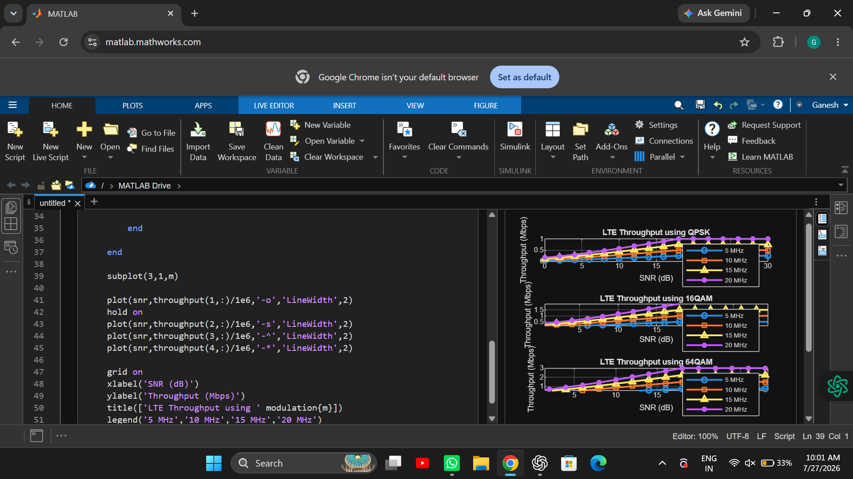

2. Simulation of LTE Protocol Stack Delay Analysis (BL4)
Aim
To analyze packet delay through the LTE protocol stack under different traffic conditions.
Parameters
- Uplink traffic
- Downlink traffic
- Packet Size: 128, 512, 1024 Bytes
- Retransmission Count: 0–5
- Channel Quality Indicator (CQI): 1–15
Procedure
- Generate uplink traffic.
- Generate downlink traffic.
- Change packet size.
- Introduce retransmissions.
- Vary channel quality.
- Measure protocol delay.
Output Graphs
- Delay vs Packet Size
- Delay vs Retransmissions
- Delay vs CQI
Expected Result
- Larger packets increase delay.
- More retransmissions increase delay.
- Better channel quality reduces delay.
Code:
clc;
clear;
close all;

packetSize = [128 256 512 1024 1500];
retransmission = 0:5;
CQI = 1:15;

%% Delay vs Packet Size
delay_packet = packetSize*0.02;

figure;
plot(packetSize,delay_packet,'-o','LineWidth',2);
grid on;
xlabel('Packet Size (Bytes)');
ylabel('Delay (ms)');
title('Delay vs Packet Size');

%% Delay vs Retransmission
delay_retx = 10 + retransmission*5;

figure;
plot(retransmission,delay_retx,'-s','LineWidth',2);
grid on;
xlabel('Retransmission Count');
ylabel('Delay (ms)');
title('Delay vs Retransmissions');

%% Delay vs CQI
delay_cqi = 60./CQI;

figure;
plot(CQI,delay_cqi,'-*','LineWidth',2);
grid on;
xlabel('CQI');
ylabel('Delay (ms)');
title('Delay vs Channel Quality');

output:
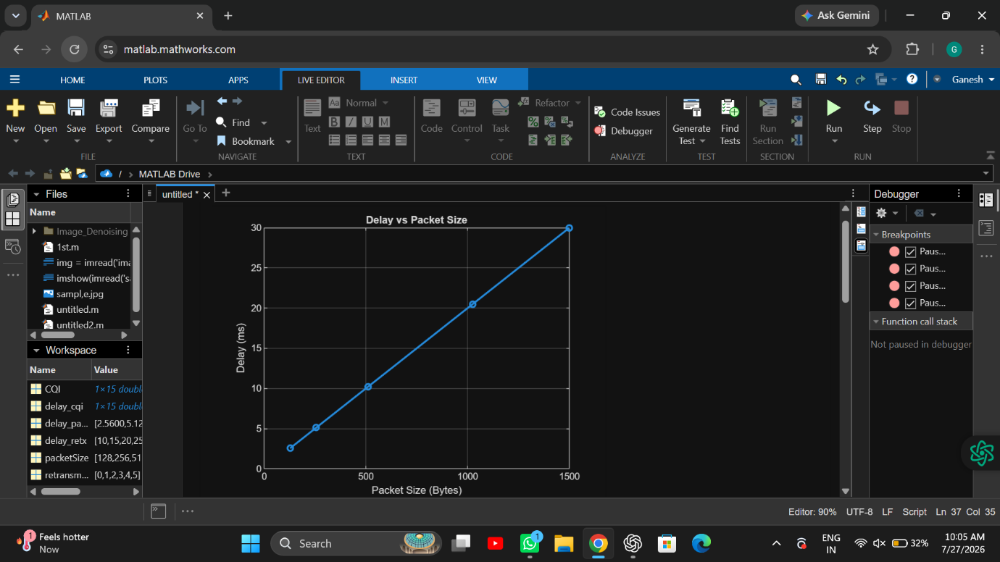
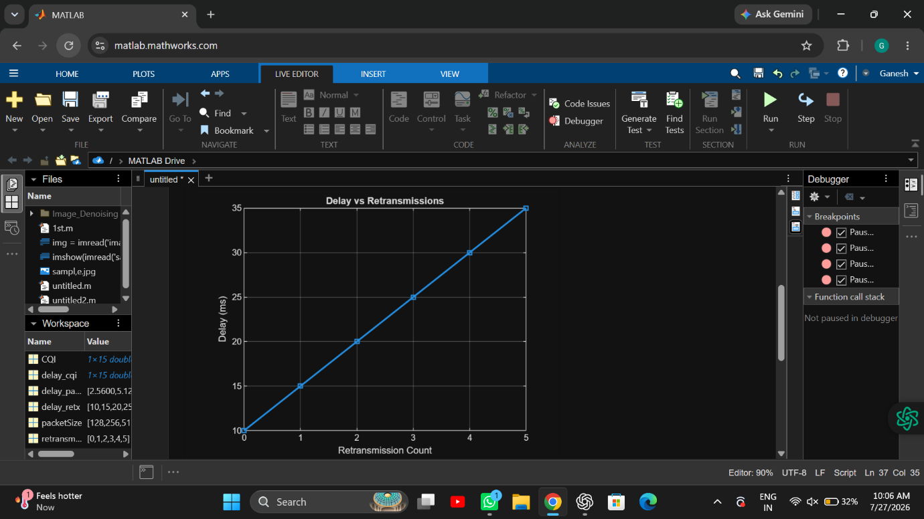
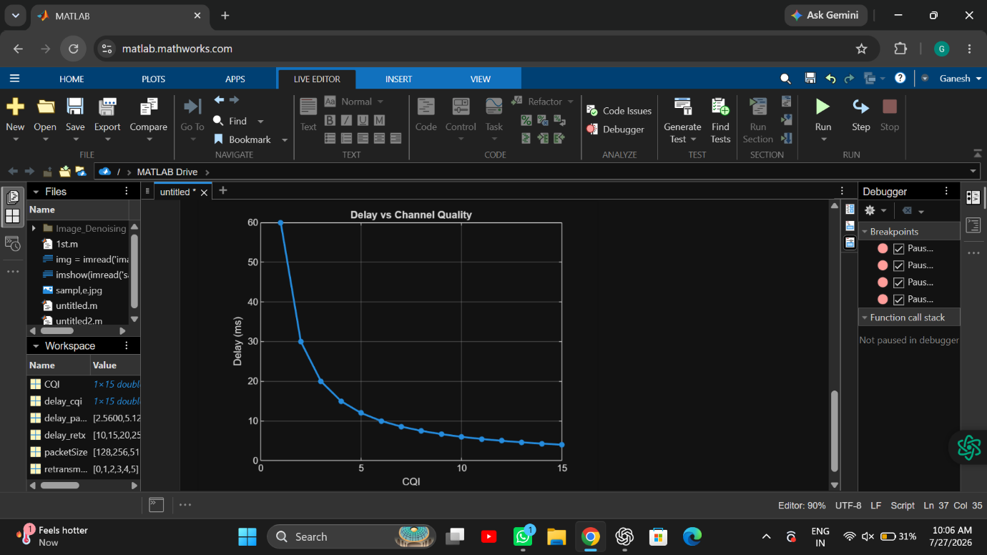

3. Simulation of Carrier Aggregation Performance in LTE-Advanced (BL4)
Aim
To evaluate throughput improvement using carrier aggregation.
Parameters
- Single Carrier
- Dual Carrier
- Triple Carrier
- Bandwidth: 10–20 MHz
- SNR: 0–30 dB
Procedure
- Configure LTE network.
- Enable single carrier.
- Enable dual carrier.
- Enable triple carrier.
- Measure throughput.
Output Graphs
- Throughput vs Number of Carriers
- Throughput vs SNR
Expected Result
- Triple carrier provides maximum throughput.
- Throughput increases with SNR.
- Carrier aggregation improves spectral efficiency.
Code:
clc;
clear;
close all;

snr = 0:2:30;

single = zeros(size(snr));
dual = zeros(size(snr));
triple = zeros(size(snr));

for i=1:length(snr)

factor = log2(1+10^(snr(i)/10));

single(i)=20*factor;
dual(i)=40*factor;
triple(i)=60*factor;

end

figure;

plot(snr,single,'LineWidth',2);
hold on
plot(snr,dual,'LineWidth',2);
plot(snr,triple,'LineWidth',2);

grid on

xlabel('SNR (dB)')
ylabel('Throughput (Mbps)')
title('Carrier Aggregation Performance')

legend('Single Carrier','Dual Carrier','Triple Carrier')

output:
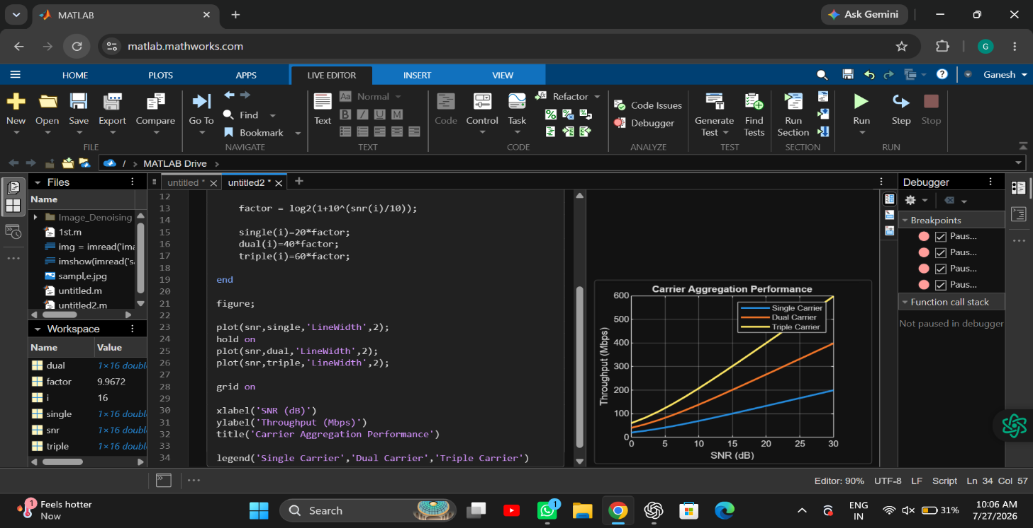

4. Simulation of LTE Resource Block Allocation (BL4)
Aim
To analyze resource block allocation under varying network conditions.
Parameters
- Users: 10–100
- Scheduling: Round Robin, Proportional Fair
- Bandwidth: 5–20 MHz
- Traffic Load: Low, Medium, High
- Interference: Low, Medium, High
Procedure
- Create LTE cell.
- Increase users.
- Change scheduler.
- Increase traffic load.
- Add interference.
- Observe RB allocation.
Output Graphs
- Resource Blocks vs Users
- Throughput vs Traffic Load
- Resource Utilization vs Interference
Expected Result
- More users require more RB sharing.
- High interference reduces RB efficiency.
- Wider bandwidth provides more RBs.
Code:
clc;
clear;
close all;

users = 10:10:100;

RB = 100;

RBperUser = RB./users;

figure

plot(users,RBperUser,'-o','LineWidth',2)

grid on

xlabel('Number of Users')

ylabel('Resource Blocks/User')

title('LTE Resource Block Allocation')

traffic = [20 40 60 80 100];

throughput = [95 85 70 55 40];

figure

bar(traffic,throughput)

xlabel('Traffic Load (%)')

ylabel('Throughput (%)')

title('Traffic Load vs Throughput')

grid on

output:
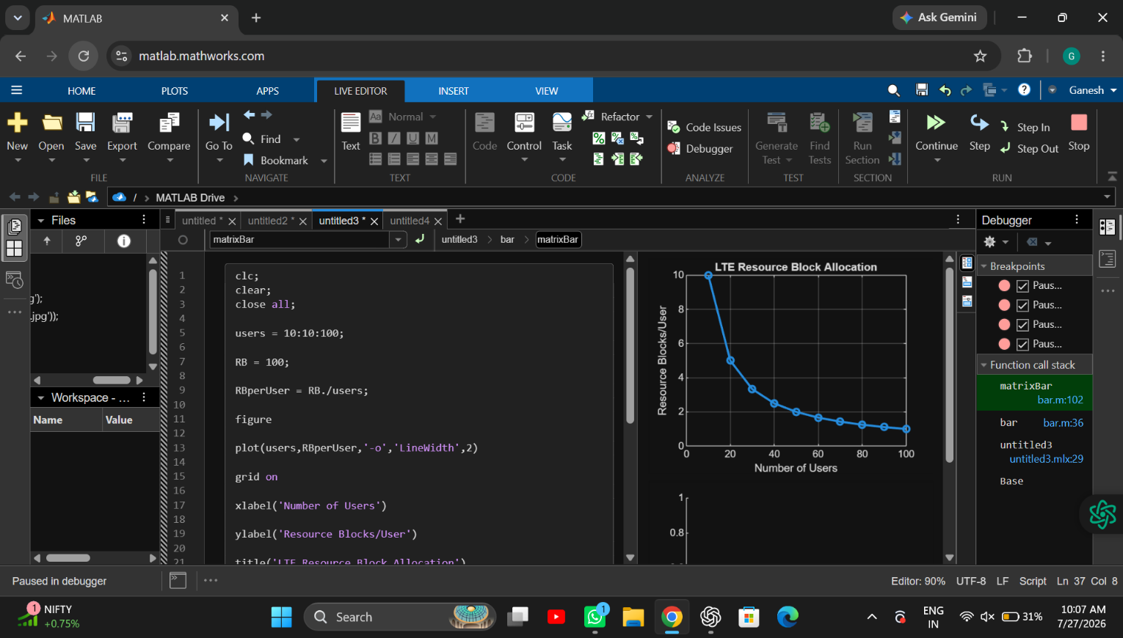

5. Simulation of LTE Scheduler Performance (BL4)
Aim
To compare LTE scheduling algorithms.
Scheduling Algorithms
- Round Robin (RR)
- Proportional Fair (PF)
- Max C/I
Parameters
- Scheduler Type
- Delay
- Throughput
- Fairness
- Number of Users
Procedure
- Select scheduler.
- Generate LTE traffic.
- Run simulation.
- Measure throughput.
- Measure delay.
- Compare fairness.
Output Graphs
- Throughput Comparison
- Delay Comparison
- Fairness Index
Code:
clc;
clear;
close all;

users = 10:10:100;

RR = 25 + users*0.5;

PF = 35 + users*0.7;

MAXCI = 45 + users*0.9;

figure

plot(users,RR,'LineWidth',2)

hold on

plot(users,PF,'LineWidth',2)

plot(users,MAXCI,'LineWidth',2)

grid on

xlabel('Number of Users')

ylabel('Throughput (Mbps)')

title('Scheduler Throughput Comparison')

legend('Round Robin','Proportional Fair','Max C/I')

delayRR = 20 + users*0.2;

delayPF = 15 + users*0.15;

delayMAX = 10 + users*0.1;

figure

plot(users,delayRR,'LineWidth',2)

hold on

plot(users,delayPF,'LineWidth',2)

plot(users,delayMAX,'LineWidth',2)

grid on

xlabel('Number of Users')

ylabel('Delay (ms)')

title('Scheduler Delay Comparison')

legend('Round Robin','Proportional Fair','Max C/I')

output:
